COVID-19 Contact Tracing Report

Table of Contents

1. VALUE BOX SUMMARIES 3

2. New contacts (starting follow-up on May 25, 2021) 4

2.1. 4

2.1.1. New contacts bar chart 5

2.1.2. New contacts sunburst plot 5

2.1.3. New contacts table 5

3. New contacts, trend over time 6

3.1. 6

3.1.1. Absolute numbers 7

3.1.2. Relative proportions 7

4. Total/cumulative contacts (as at May 25, 2021) 8

4.1. 8

4.1.1. Cumulative contacts bar chart 9

4.1.2. Cumulative contacts sunburst plot 9

4.1.3. Cumulative contacts table 9

5. Total/cumulative contacts, trend over time 10

5.1. 10

5.1.1. Absolute numbers 11

5.1.2. Relative proportions 11

6. Contacts under surveillance (as at May 25, 2021) 12

6.1. 12

6.1.1. Contacts under surveillance bar chart 13

6.1.2. Contacts under surveillance sunburst plot 13

6.1.3. Contacts under surveillance table 13

7. Contacts under surveillance, trend over time 14

7.1. 14

7.1.1. Absolute numbers 15

7.1.2. Relative proportions 15

8. Contacts per case 16

8.1. 16

8.1.1. Contacts per case, table 16

8.1.2. Contacts per case, donut plot 17

8.1.3. Contacts per case, bar chart 17

9. Case-contact relationships 18

9.1. 18

9.1.1. Case-contact relationships, donut plot 19

9.1.2. Case-contact relationships, bar chart 19

10. Follow-up timelines 20

10.1. 20

10.1.1. Follow-up summary bar chart 21

10.1.2. Follow-up timeline snake plot 21

11. Contacts not seen recently 22

11.1. 22

11.1.1. Loss to follow-up, past 3 days 22

11.1.2. List of contacts not seen 22

# VALUE BOX SUMMARIES

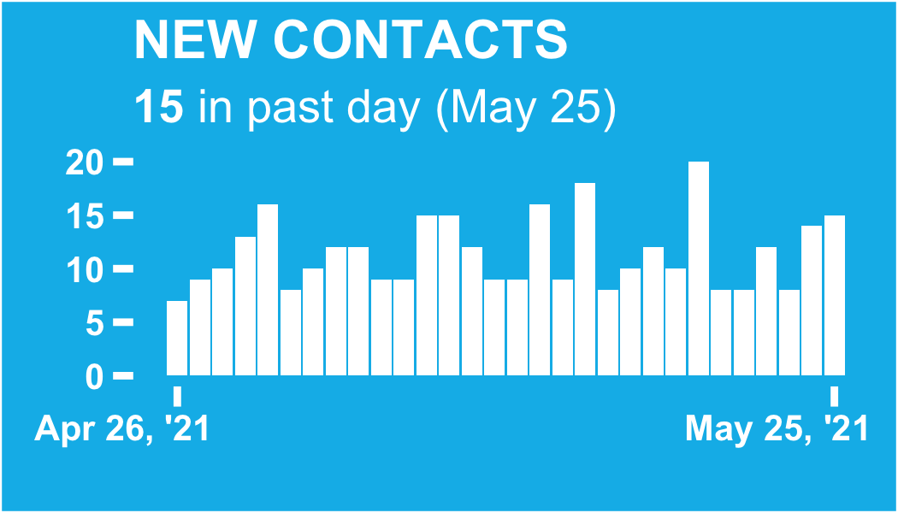

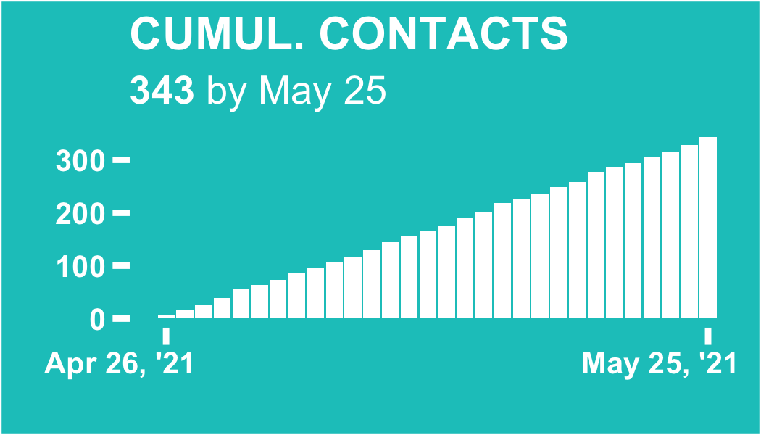

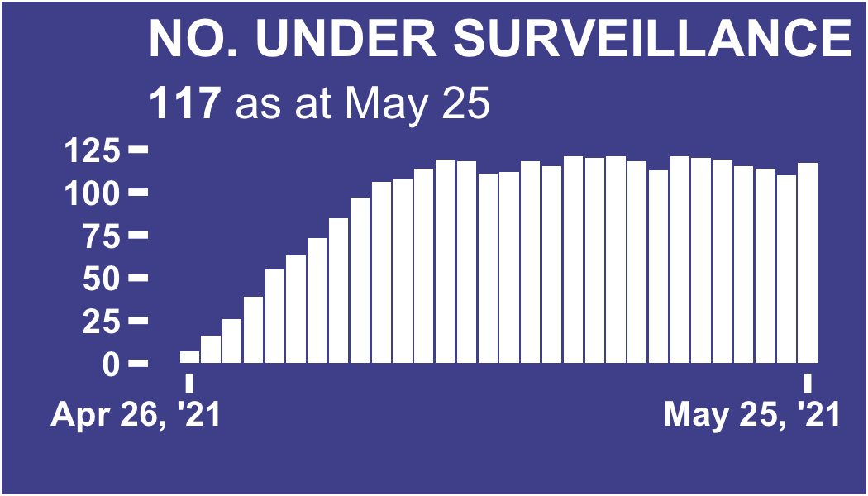

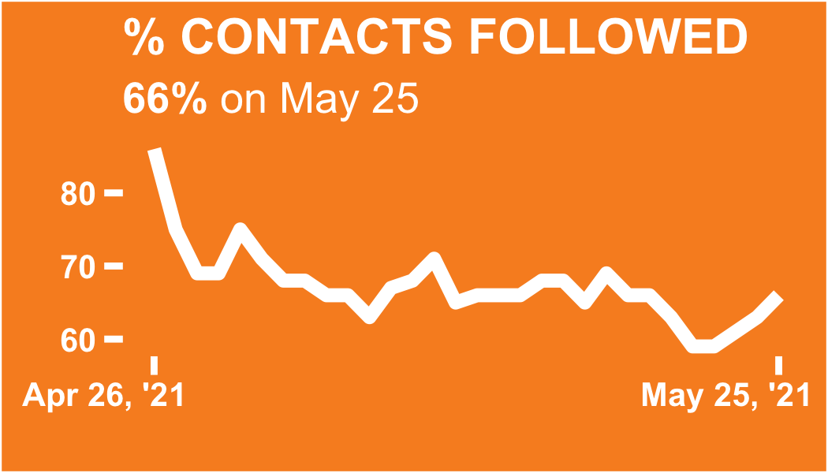

# New contacts (starting follow-up on May 25, 2021)

## 

ℹ: The table and plots show the count of the new contacts (contacts commencing follow-up) on the selected date of review. Follow-up begins the day after the last interaction with a confirmed or suspected case

The level 1 division with the most new contacts in the past day is Big City, with 10 contacts (66.7% of the total)

### New contacts bar chart

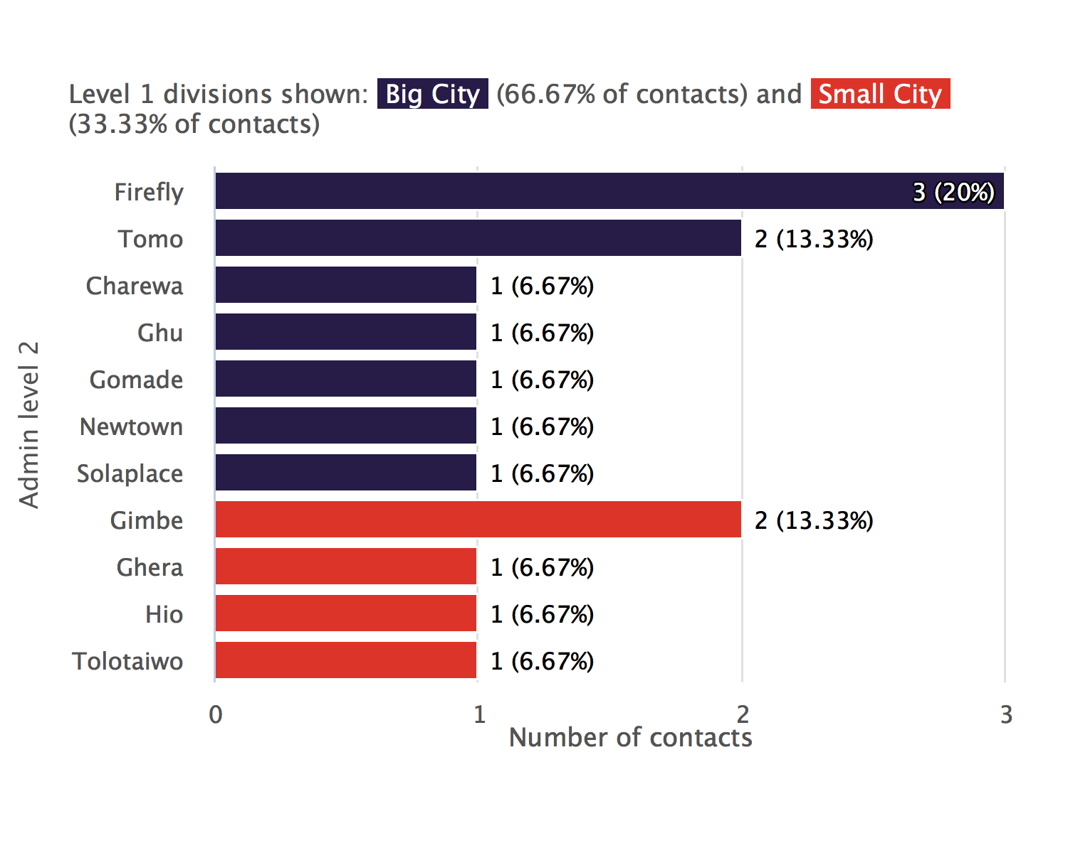

### New contacts sunburst plot

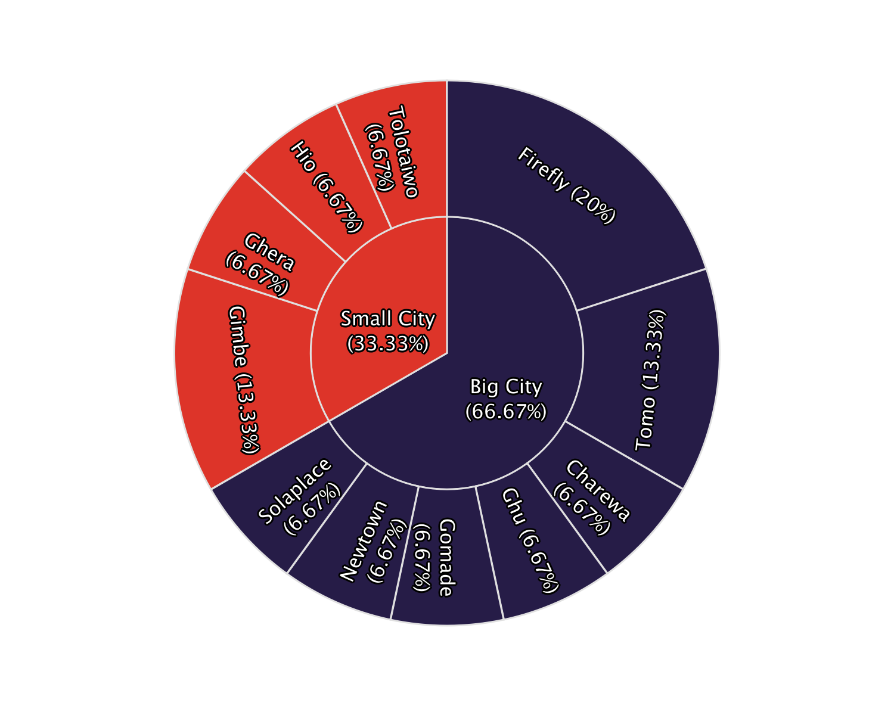

### New contacts table

|  |  |  |  |
| --- | --- | --- | --- |
| **Admin level 1** | **Admin level 2** | **New contacts today** | **%** |
| Big City | Firefly | 3 | 20 |
| Tomo | 2 | 13.3 |
| Charewa | 1 | 6.67 |
| Ghu | 1 | 6.67 |
| Gomade | 1 | 6.67 |
| Newtown | 1 | 6.67 |
| Solaplace | 1 | 6.67 |
| Small City | Gimbe | 2 | 13.3 |
| Ghera | 1 | 6.67 |
| Hio | 1 | 6.67 |
| Tolotaiwo | 1 | 6.67 |
| Total | - | 15 | 100 |

# New contacts, trend over time

## 

ℹ: The plots show the number of new contacts on each day, that is, the number of contacts on their first day of follow-up.

The day on which the highest number of new contacts commenced follow-up was May 19, 2021, with 20 contacts that day.

### Absolute numbers

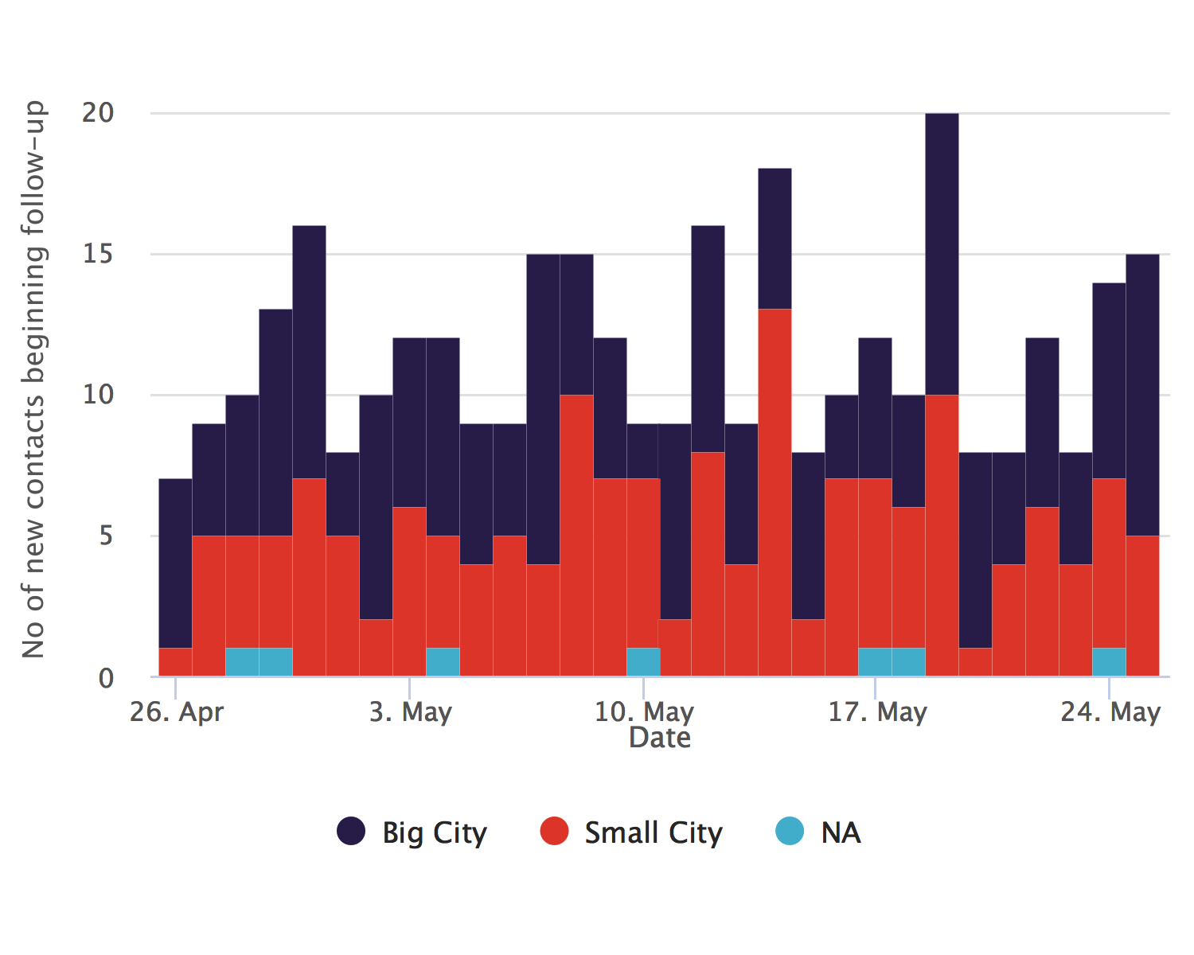

### Relative proportions

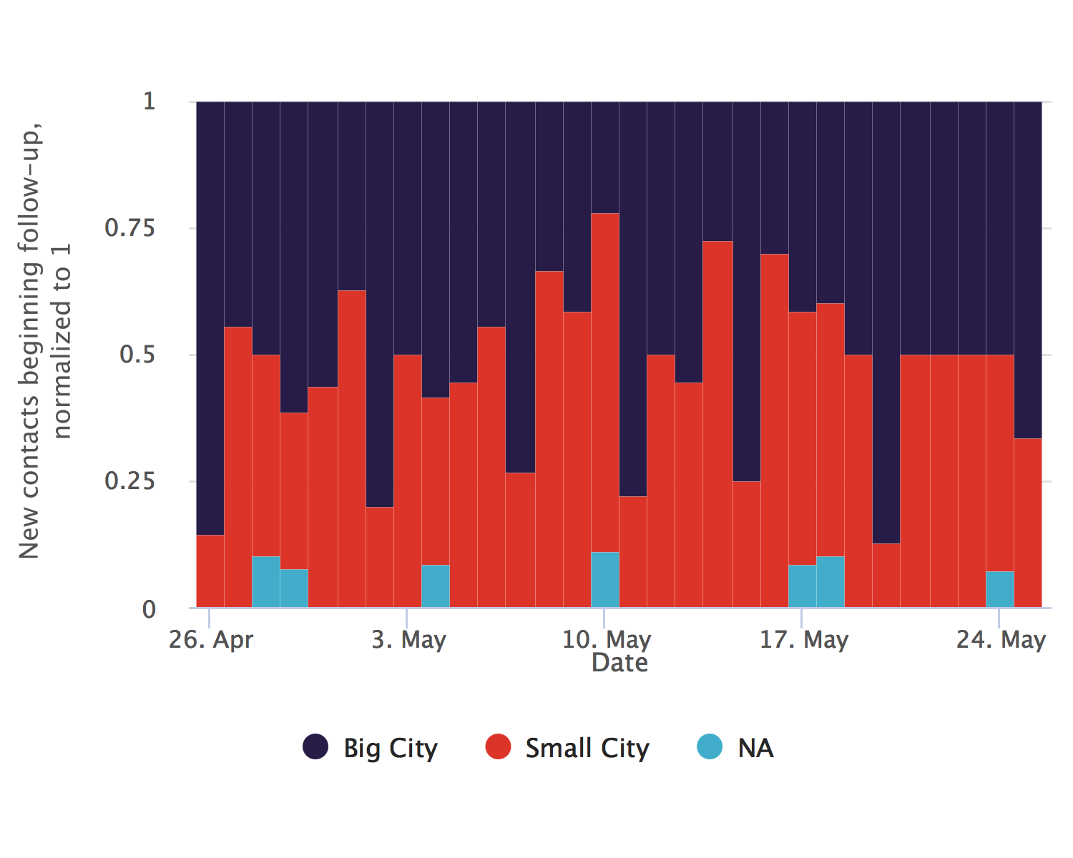

# Total/cumulative contacts (as at May 25, 2021)

## 

ℹ: The table and plots show the count of all contacts recorded in each level 1 division since database inception.

The level 1 division with the most total contacts since database inception is Big City, with 179 contacts (52.2% of the total)

### Cumulative contacts bar chart

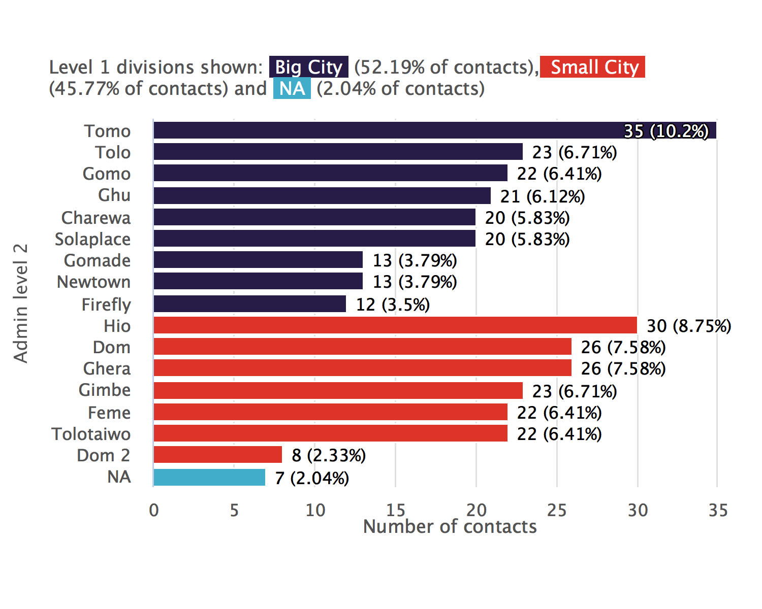

### Cumulative contacts sunburst plot

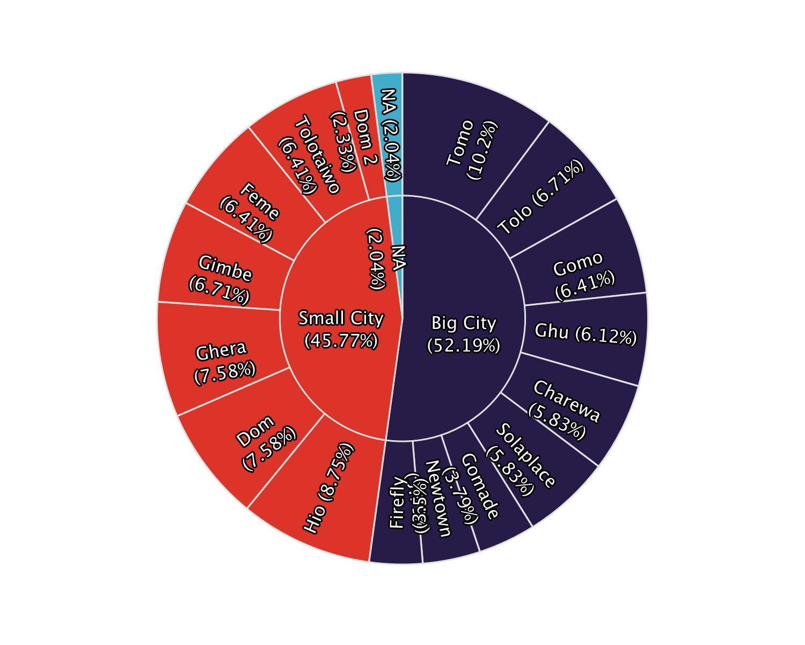

### Cumulative contacts table

|  |  |  |  |
| --- | --- | --- | --- |
| **Admin level 1** | **Admin level 2** | **Total contacts** | **%** |
| Big City | Tomo | 35 | 10.2 |
| Tolo | 23 | 6.71 |
| Gomo | 22 | 6.41 |
| Ghu | 21 | 6.12 |
| Charewa | 20 | 5.83 |
| Solaplace | 20 | 5.83 |
| Gomade | 13 | 3.79 |
| Newtown | 13 | 3.79 |
| Firefly | 12 | 3.5 |
| Small City | Hio | 30 | 8.75 |
| Dom | 26 | 7.58 |
| Ghera | 26 | 7.58 |
| Gimbe | 23 | 6.71 |
| Feme | 22 | 6.41 |
| Tolotaiwo | 22 | 6.41 |
| Dom 2 | 8 | 2.33 |
| NA | NA | 7 | 2.04 |
| Total | - | 343 | 100 |

# Total/cumulative contacts, trend over time

## 

ℹ: The table and plots show the count of cumulative contacts over time.

Today, Big City has a cumulative count of 179 contacts. Seven days ago, there were 141 contacts (a 27 % increase)

### Absolute numbers

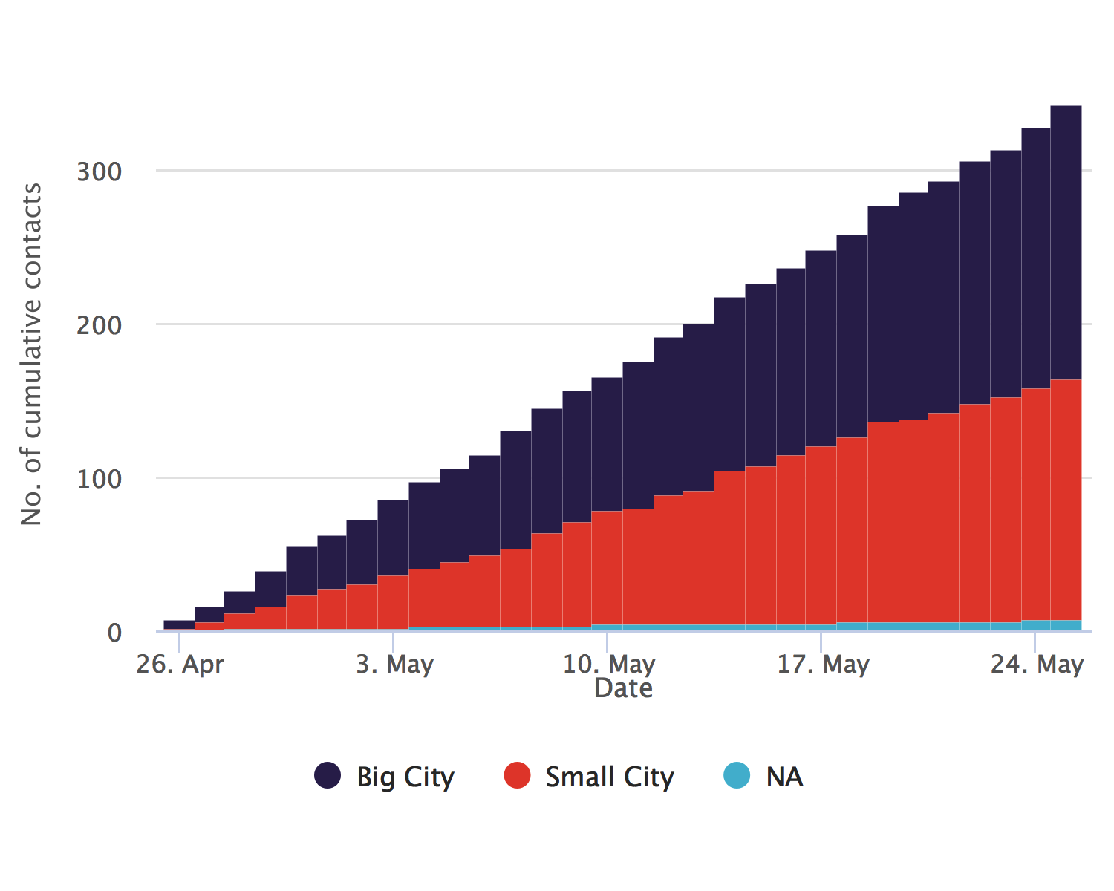

### Relative proportions

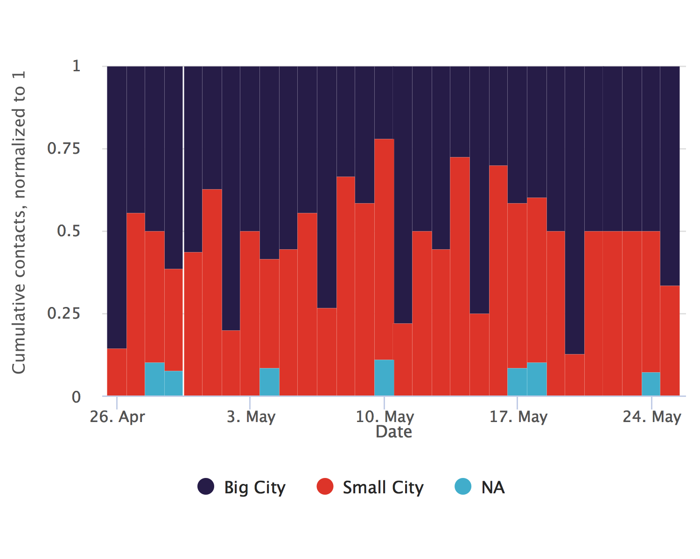

# Contacts under surveillance (as at May 25, 2021)

## 

ℹ: The table and plots show the count of contacts currently under follow-up.

The level 1 division with the most contacts under surveillance at present is Big City, with 179 contacts (52.2% of the total)

### Contacts under surveillance bar chart

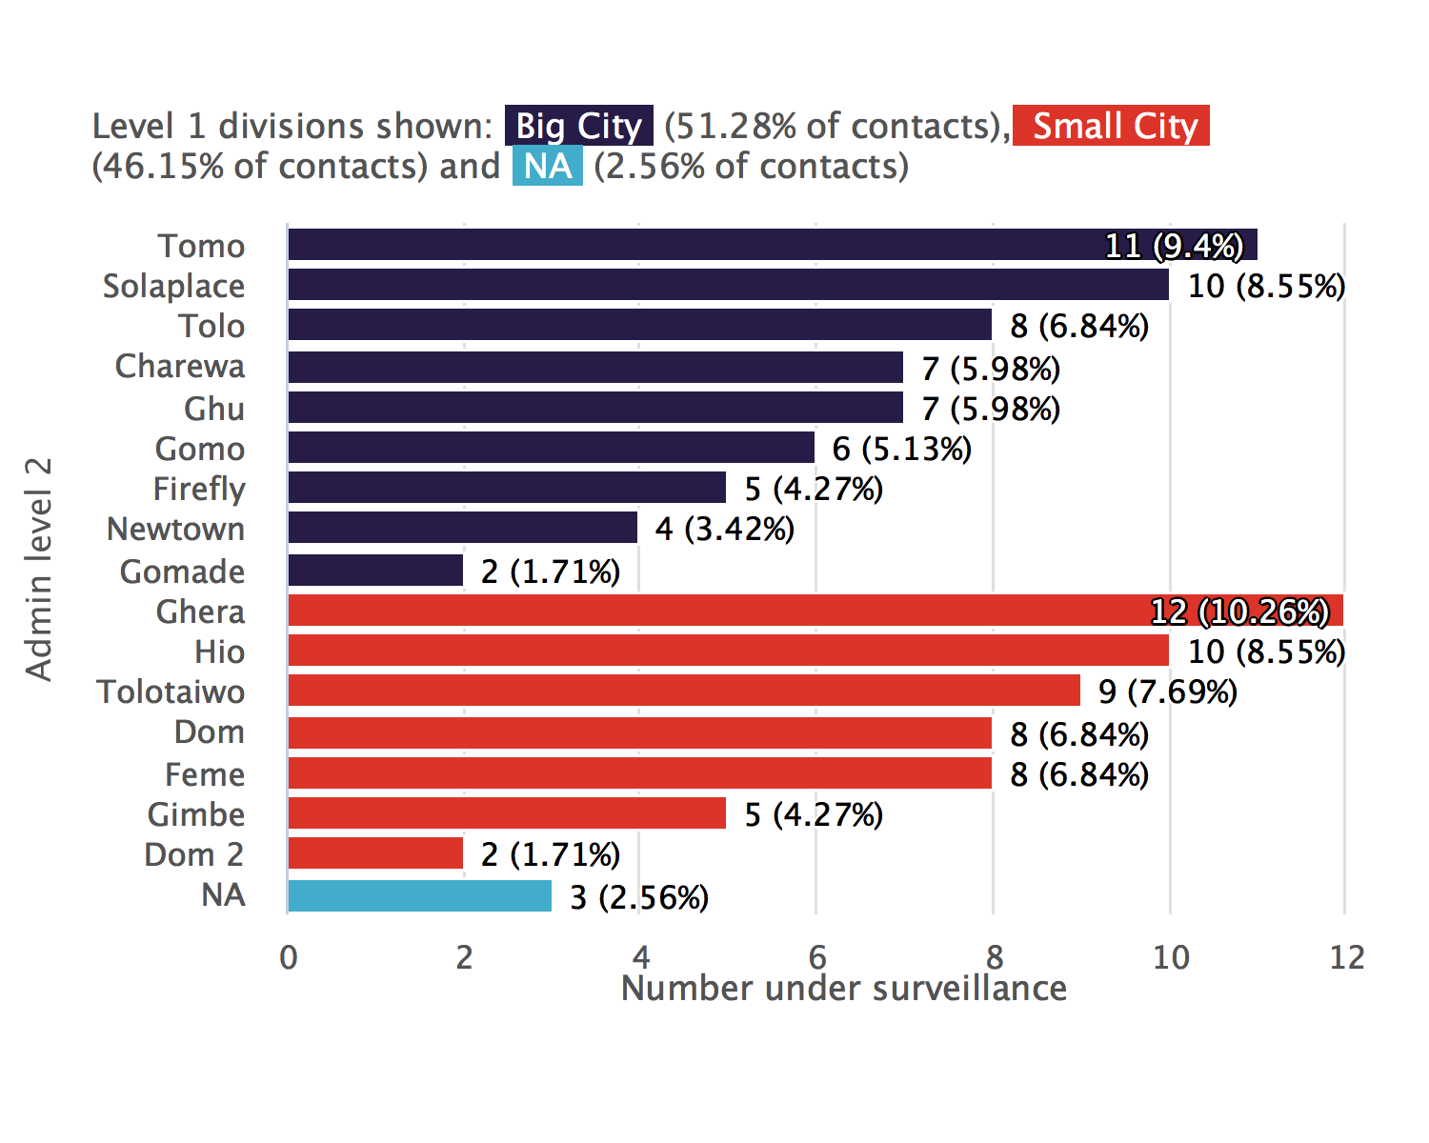

### Contacts under surveillance sunburst plot

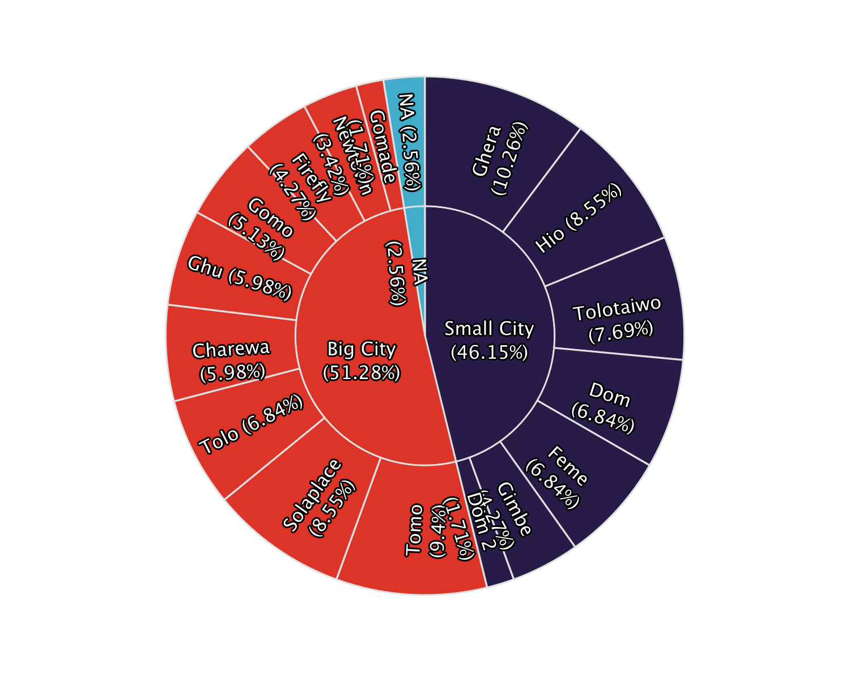

### Contacts under surveillance table

|  |  |  |  |
| --- | --- | --- | --- |
| **Admin level 1** | **Admin level 2** | **No. under surveillance** | **%** |
| Big City | Tomo | 11 | 9.4 |
| Solaplace | 10 | 8.55 |
| Tolo | 8 | 6.84 |
| Charewa | 7 | 5.98 |
| Ghu | 7 | 5.98 |
| Gomo | 6 | 5.13 |
| Firefly | 5 | 4.27 |
| Newtown | 4 | 3.42 |
| Gomade | 2 | 1.71 |
| Small City | Ghera | 12 | 10.3 |
| Hio | 10 | 8.55 |
| Tolotaiwo | 9 | 7.69 |
| Dom | 8 | 6.84 |
| Feme | 8 | 6.84 |
| Gimbe | 5 | 4.27 |
| Dom 2 | 2 | 1.71 |
| NA | NA | 3 | 2.56 |
| Total | - | 117 | 100 |

# Contacts under surveillance, trend over time

## 

ℹ: The plots show the number of contacts under surveillance on each day, whether or not they were successfully contacted.

The day on which the highest number contacts were under surveillance was May 14, 2021, with 121 contacts under surveillance.

### Absolute numbers

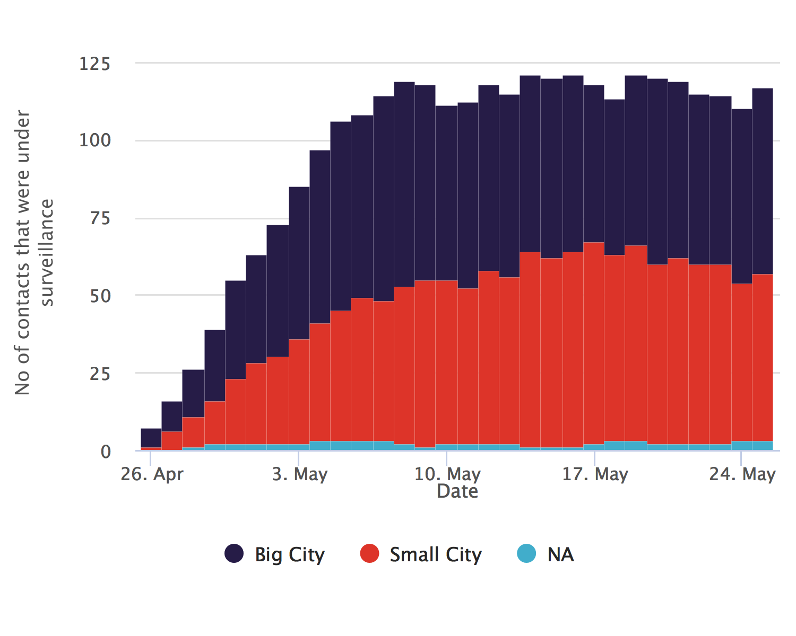

### Relative proportions



# Contacts per case

## 

ℹ: The plots show the number of contacts linked to each case.

The median number of contacts per case is 8, (IQR:15-14) with a minimum of 1 and a maximum of 16

### Contacts per case, table

Contacts per case for the 20 cases with the most contacts

|  |  |
| --- | --- |
| **Case ID** | **Total linked contacts** |
| Manquant | 16 |
| CAS20 | 15 |
| CAS15 | 14 |
| CAS19 | 14 |
| CAS34 | 14 |
| CAS29 | 13 |
| CAS8 | 13 |
| CAS21 | 12 |
| CAS25 | 12 |
| CAS38 | 12 |
| CAS1 | 11 |
| CAS7 | 11 |
| CAS9 | 11 |
| CAS36 | 10 |
| CAS14 | 9 |
| CAS26 | 9 |
| CAS3 | 9 |
| CAS39 | 9 |
| CAS5 | 9 |
| CAS10 | 8 |

### Contacts per case, donut plot

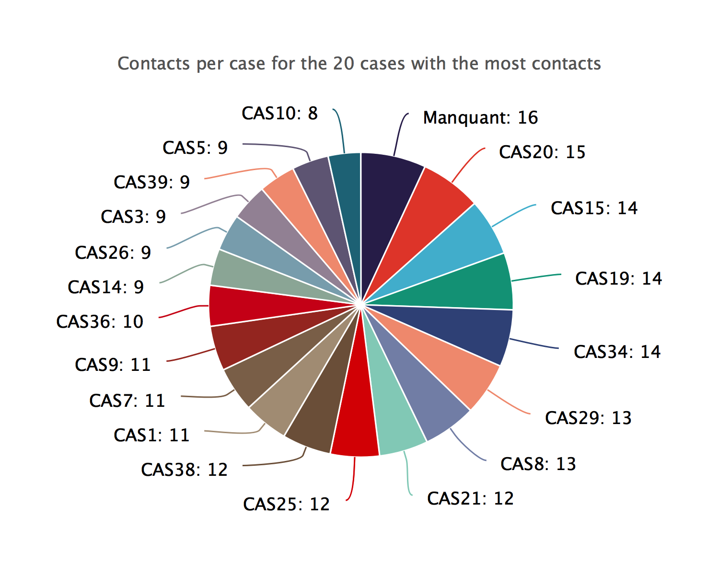

### Contacts per case, bar chart

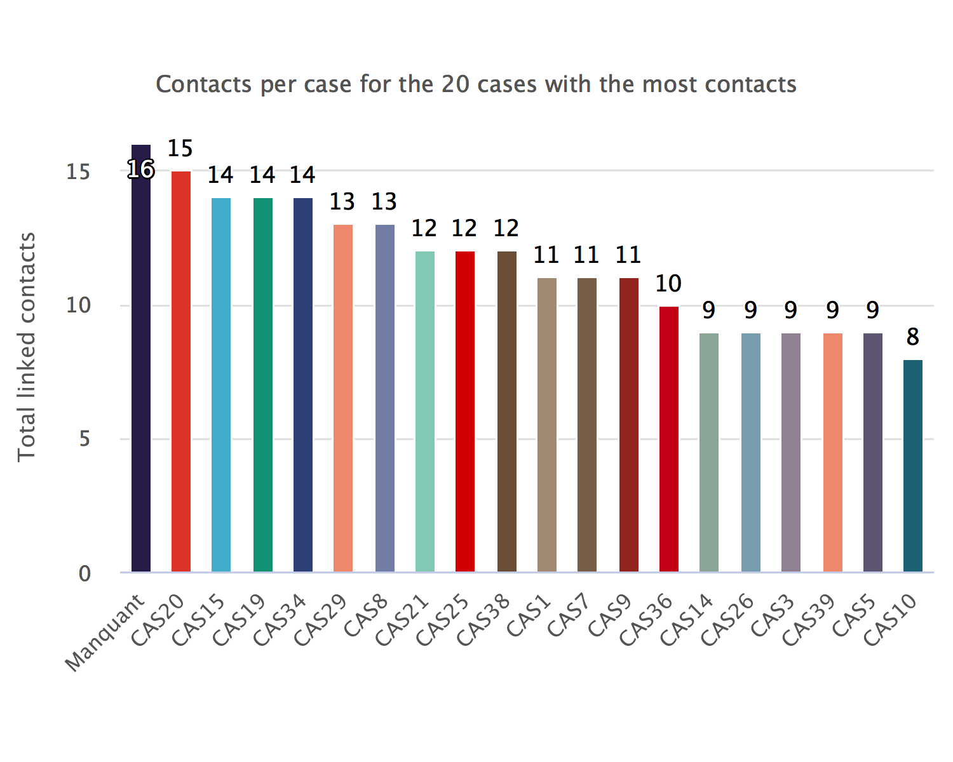

# Case-contact relationships

## 

ℹ: The plots show the number of contacts per type of link. The categories have been cleaned and condensed. Access the data in tabular form by clicking on the top-right button.

The most common link category is ‘parent proche’, with 53 contacts (15.45%).

### Case-contact relationships, donut plot

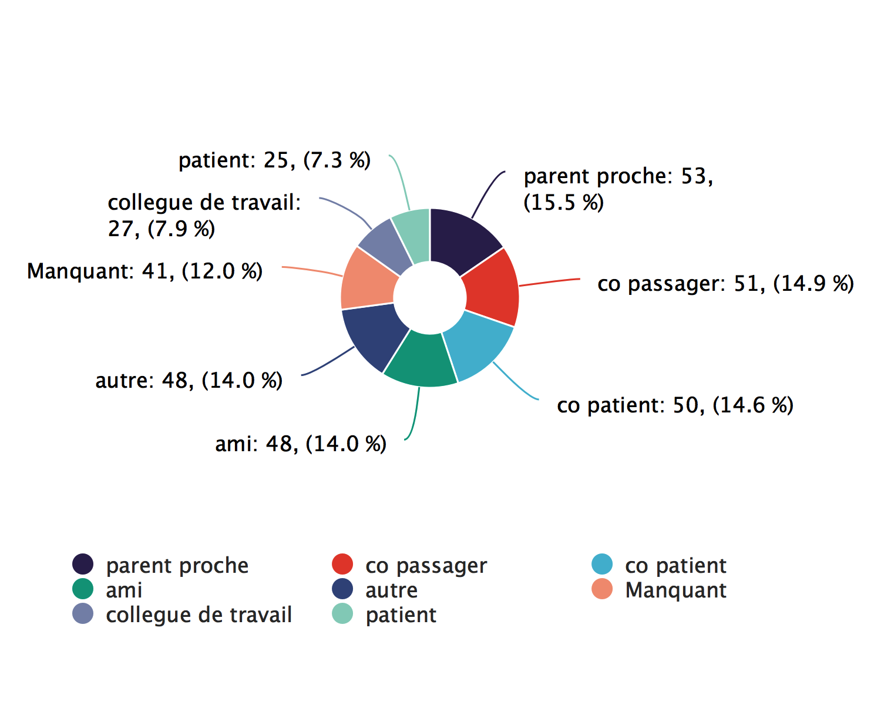

### Case-contact relationships, bar chart

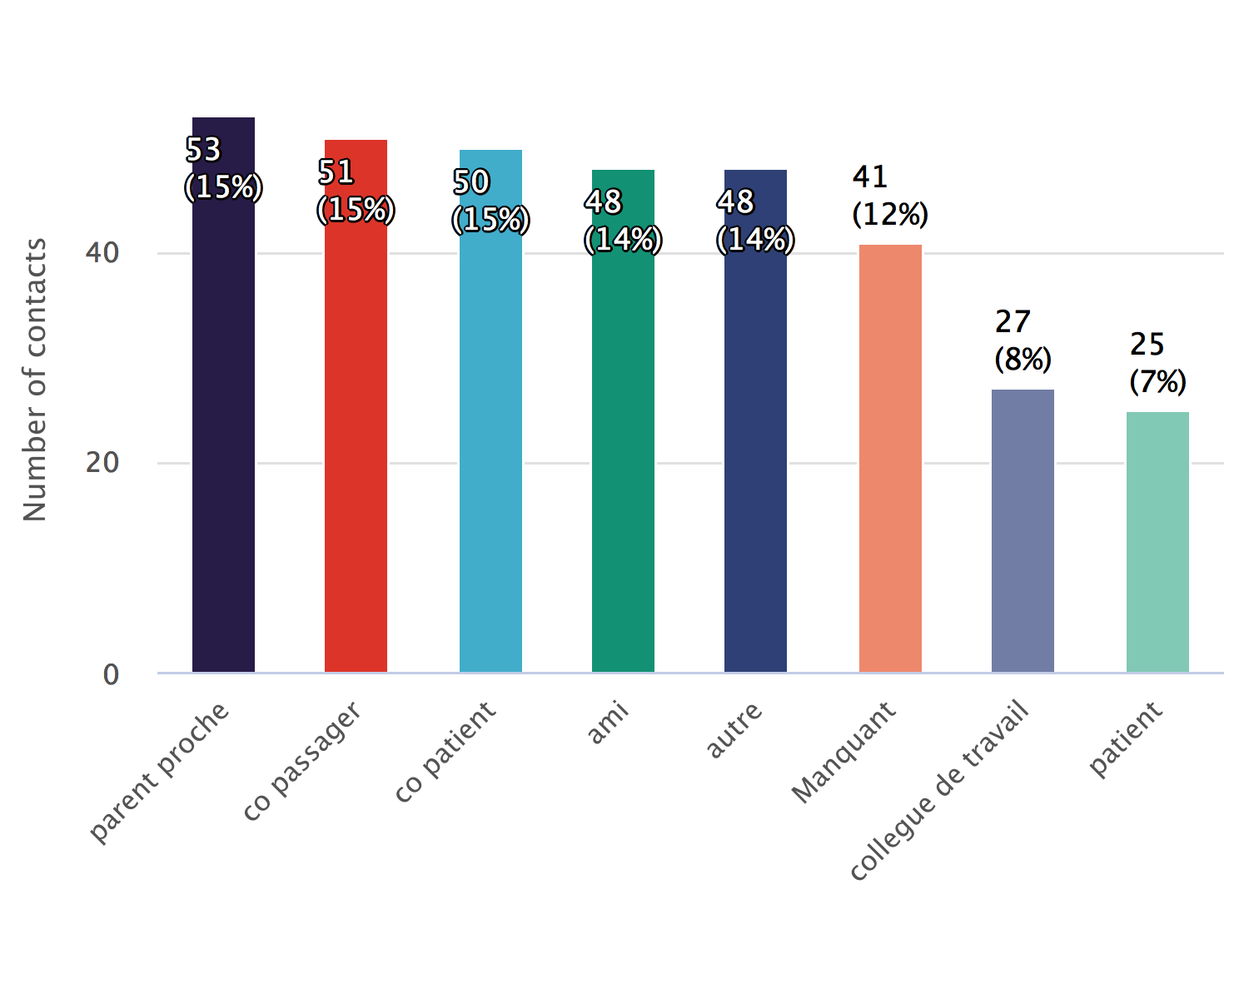

# Follow-up timelines

## 

ℹ: The plots track the status of each active contact over all 10 days of follow-up.

There are 117 active contacts

### Follow-up summary bar chart

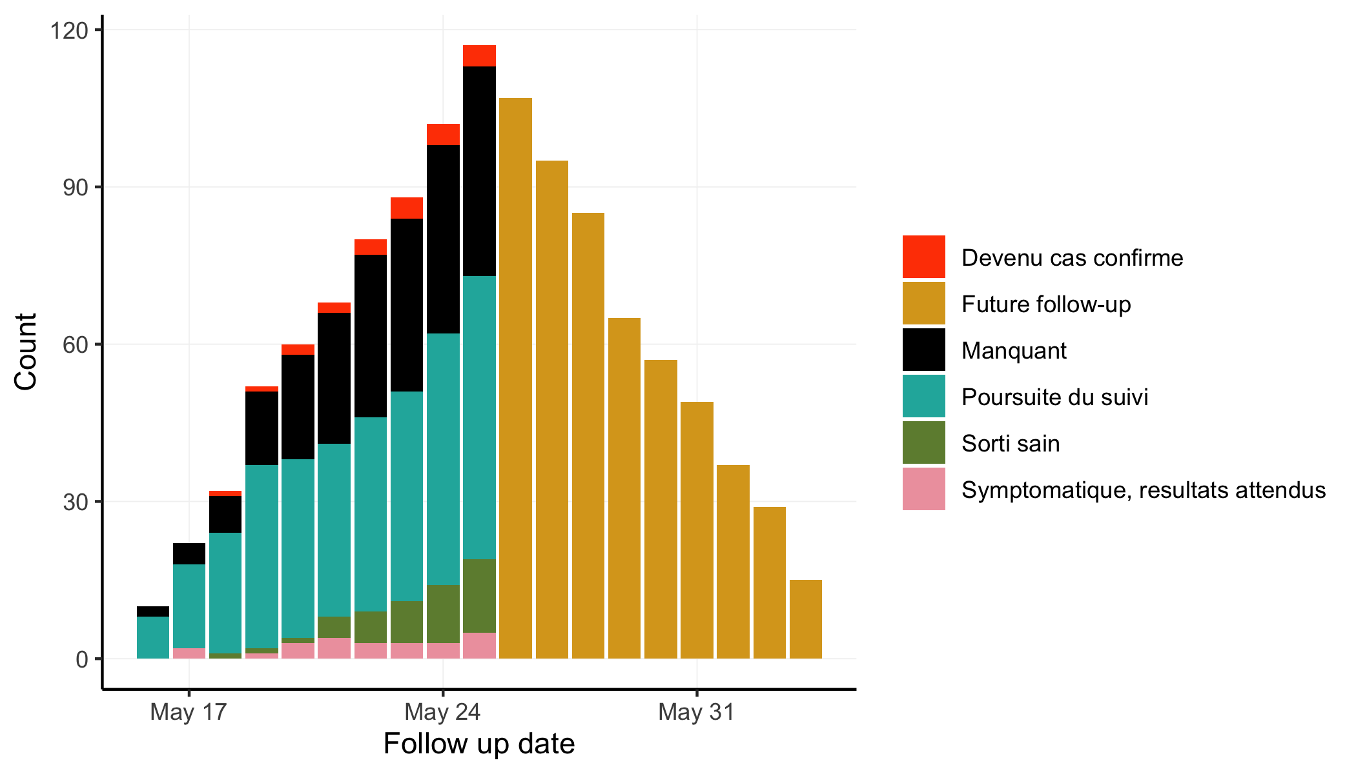

### Follow-up timeline snake plot

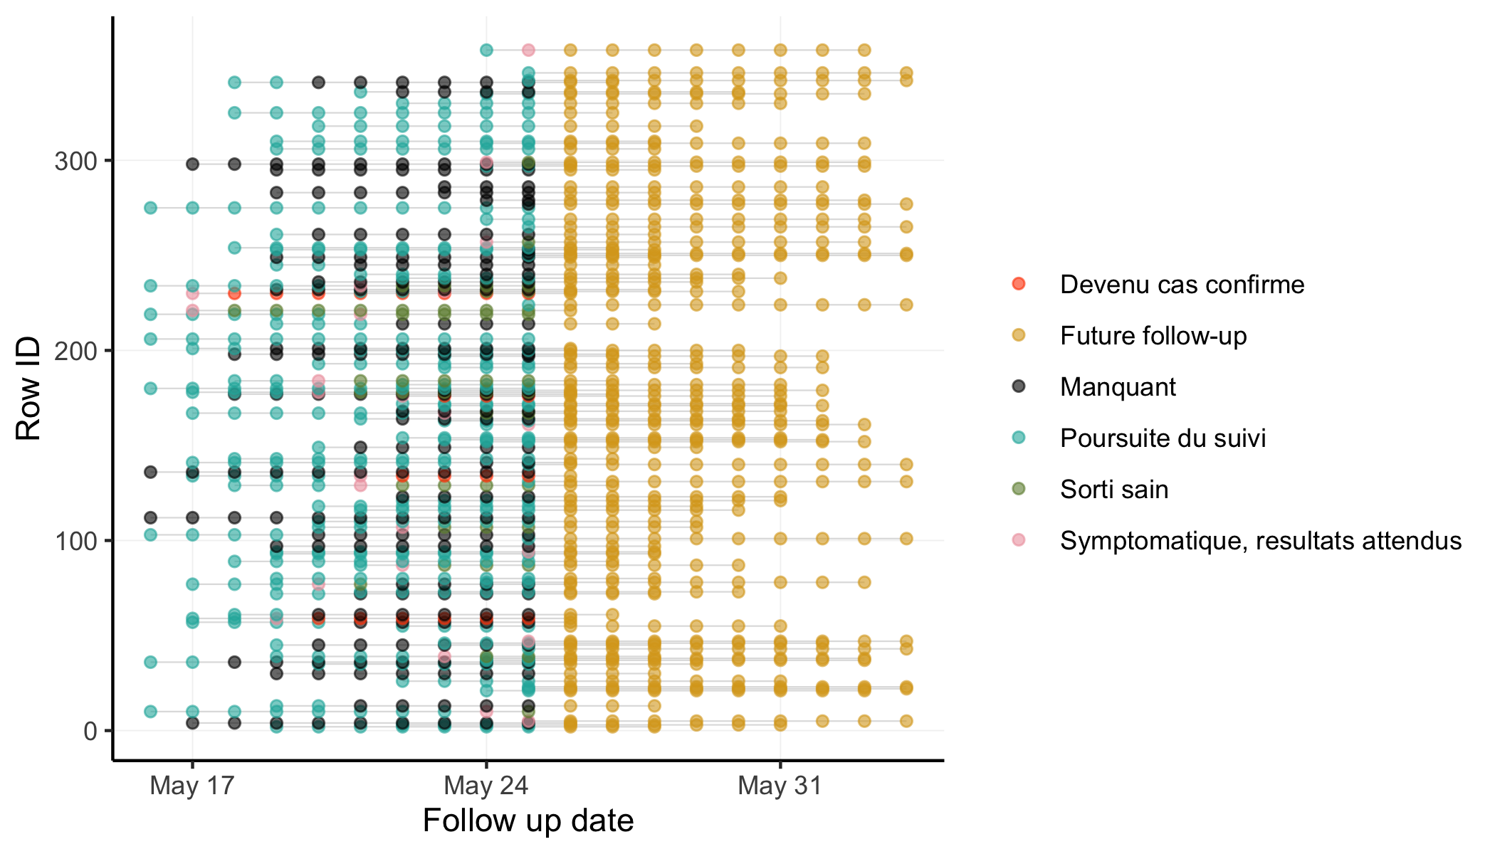

# Contacts not seen recently

## 

ℹ: The tables track the contacts who should be under surveillance but have not been followed for an extended period.

4 contacts have not been seen for the past three days.

### Loss to follow-up, past 3 days

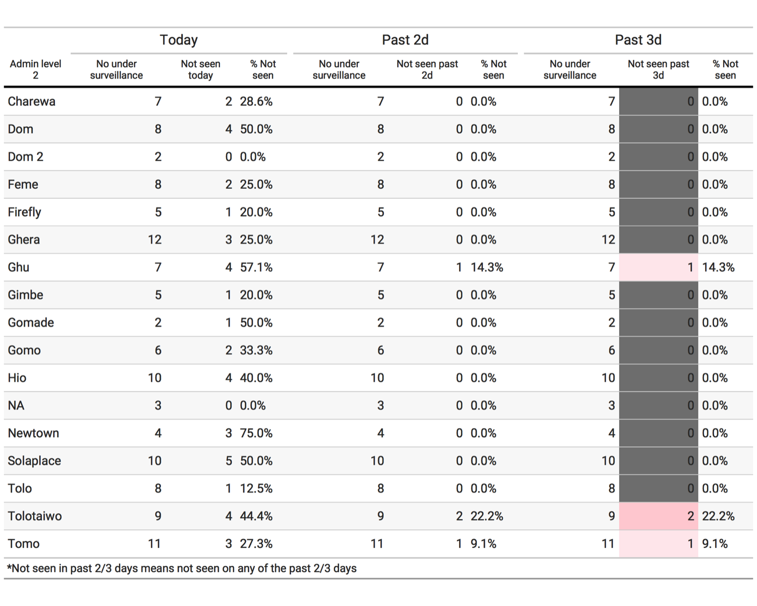

### List of contacts not seen

|  |
| --- |
| **ID** |
| Civ35 |
| Civ102 |
| Civ111 |
| Civ135 |